JOIN DURHAM VOLUNTEER POLICE CADETS
Aged 11–17? Live in County Durham or Darlington? Ready for something exciting and rewarding?
Recruiting now for September 2026
Have fun, make friends, learn new skills and make a positive difference.
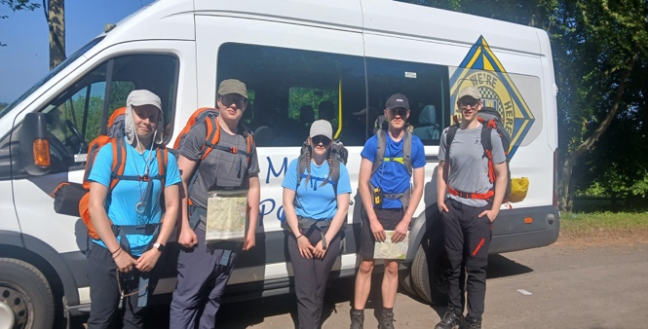 | 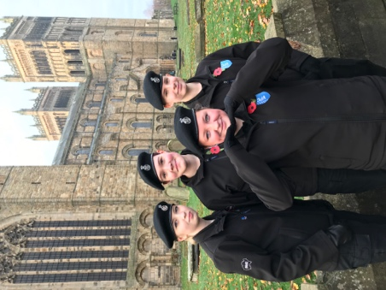 | 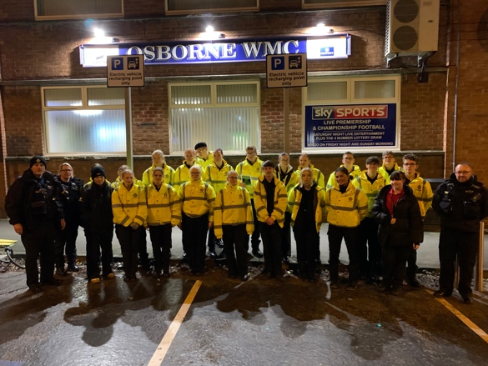ity events

Why become a cadet?
- Build confidence, teamwork and leadership skills
- Meet new people and make lasting friendships
- Learn about policing and the law
- Take part in activities, events and volunteering
- Get involved in the Duke of Edinburgh’s Award scheme
- Attend an annual outdoor activity residential
- Help make a positive difference in your community

Key dates
Induction days: Wednesday 19 August OR Wednesday 26 August 2026
Start date: September 2026
Applications close at 10am on Friday 14 August 2026
Don’t miss your chance to be part of a great team.
Interested?
Fill out the online application form

